
HEMANTH P
192472285
ONE-SHOT TEXT CLASSIFICATION: COMPARISON WITH ZERO-SHOT APPROACH
1. INTRODUCTION
Text classification is an important task in Natural Language Processing (NLP). It is used to assign a category or label to a given text.
Large Language Models (LLMs) can perform text classification using prompts without training a separate machine learning model. Two important prompting methods are Zero-Shot Prompting and One-Shot Prompting.
In this experiment, sentiment classification is performed using three categories: Positive, Negative, and Neutral. The results of Zero-Shot and One-Shot Prompting are compared.

2. AIM
To implement text classification using One-Shot Prompting and compare its performance with Zero-Shot Prompting using a Gemini Large Language Model.

3. OBJECTIVES
- To understand text classification.
- To understand Zero-Shot Prompting.
- To understand One-Shot Prompting.
- To implement sentiment classification using Gemini API.
- To compare the results of both prompting methods.
- To analyze the effectiveness of providing an example.

4. THEORETICAL BACKGROUND
4.1 Text Classification
Text classification is the process of assigning predefined labels to text.
For example:
- "The movie was excellent." → Positive
- "The service was terrible." → Negative
- "The class starts at 10 AM." → Neutral
4.2 Natural Language Processing
NLP enables computers to understand and process human language. It is used in sentiment analysis, chatbots, translation, search engines, and text classification.
4.3 Large Language Models
LLMs are AI models trained on large amounts of text. They can understand instructions and perform tasks such as classification, summarization, and question answering.

5. ZERO-SHOT PROMPTING
Zero-Shot Prompting means performing a task without providing any example.
Example prompt:
Classify the sentiment as Positive, Negative, or Neutral.

Sentence: The food was delicious.

Answer:
Advantages
- No example is required.
- Simple to implement.
- Uses a shorter prompt.
- Suitable for simple classification tasks.
Limitation
The model may sometimes misunderstand the task when the categories or instructions are unclear.

6. ONE-SHOT PROMPTING
One-Shot Prompting provides one example before asking the model to classify new text.
Example:
Sentence: The movie was excellent.
Sentiment: Positive

Now classify:
Sentence: The food was delicious.

Answer:
Advantages
- Provides guidance to the model.
- Shows the expected output format.
- Can improve consistency.
- Useful for specialized classification tasks.
Limitation
It requires additional prompt information and tokens.

7. ZERO-SHOT VS ONE-SHOT
Feature | Zero-Shot | One-Shot
Example | Not provided | One example
Prompt length | Short | Longer
Guidance | Low | Higher
Implementation | Simple | Simple
Output consistency | May vary | Often more consistent
8. METHODOLOGY
The experiment follows these steps:
- Select sentiment classification as the task.
- Define three labels: Positive, Negative, and Neutral.
- Prepare sample sentences.
- Create a Zero-Shot prompt.
- Create a One-Shot prompt with one example.
- Send both prompts to Gemini API.
- Collect the classification results.
- Compare the results.
Tools Used
- Python
- Gemini API
- Google GenAI Library
- Gemini Flash Model
- Internet Connection

9. DATASET
The following sample sentences are used:
No. | Sentence | Expected Class
1 | The movie was fantastic. | Positive
2 | The food was delicious. | Positive
3 | The service was terrible. | Negative
4 | The product quality is poor. | Negative
5 | The parcel arrived today. | Neutral
6 | The class starts at 10 AM. | Neutral
7 | I loved the new phone. | Positive
8 | The experience was disappointing. | Negative
9 | The laptop has 8 GB RAM. | Neutral
10 | The hotel room was beautiful. | Positive

10. ZERO-SHOT IMPLEMENTATION
The Zero-Shot prompt directly asks Gemini to classify the input without providing an example.
from google import genai

client = genai.Client(api_key="YOUR_API_KEY")

text = "The food was delicious."

prompt = f"""
Classify the sentiment as Positive, Negative, or Neutral.

Sentence: {text}

Give only one label.
"""

response = client.models.generate_content(
model="YOUR_AVAILABLE_GEMINI_MODEL",
contents=prompt
)

print("Zero-Shot Result:")
print(response.text)
Expected Output
Zero-Shot Result:
Positive

11. ONE-SHOT IMPLEMENTATION
The One-Shot prompt provides one example before asking Gemini to classify the new sentence.
from google import genai

client = genai.Client(api_key="YOUR_API_KEY")

text = "The food was delicious."

prompt = f"""
Classify the sentiment as Positive, Negative, or Neutral.

Example:
Sentence: The movie was excellent.
Sentiment: Positive

Now classify:
Sentence: {text}

Give only one label.
"""

response = client.models.generate_content(
model="YOUR_AVAILABLE_GEMINI_MODEL",
contents=prompt
)

print("One-Shot Result:")
print(response.text)
Expected Output
One-Shot Result:
Positive

12. RESULTS AND COMPARISON

The results obtained from both approaches can be recorded and compared.
Method | Input | Result
Zero-Shot | The food was delicious. | Positive
One-Shot | The food was delicious. | Positive
Both methods can correctly identify the positive sentiment in this example.
For the final experiment, multiple sentences should be tested to compare the performance more effectively.

13. ACCURACY
Accuracy measures the percentage of correctly classified sentences.
Formula:
Accuracy = (Correct Predictions / Total Predictions) × 100
For example, if 9 out of 10 predictions are correct:
Accuracy = (9 / 10) × 100 = 90%
The accuracy of Zero-Shot and One-Shot approaches can be calculated separately and compared.

14. ANALYSIS
Zero-Shot Prompting can perform classification without any example and is suitable for simple tasks.
One-Shot Prompting provides an example that gives additional guidance to the model. It can help the model understand the expected classification and output format.
The performance of both methods depends on the clarity of the prompt and the complexity of the input text.
15. APPLICATIONS
Text classification using prompting can be used in:
- Sentiment analysis.
- Spam detection.
- Customer feedback analysis.
- Email classification.
- News classification.
- Social media analysis.
- Product review classification.

16. ADVANTAGES AND LIMITATIONS
Advantages
- Easy to implement.
- No model training is required.
- Works with natural language instructions.
- One-Shot Prompting provides task-specific guidance.
Limitations
- Results may vary depending on the prompt.
- API quota can affect execution.
- Complex text may be difficult to classify.
- One-Shot Prompting requires an additional example.

17. CONCLUSION
This experiment demonstrates text classification using Zero-Shot and One-Shot Prompting.
Zero-Shot Prompting performs classification without an example, while One-Shot Prompting provides one example to guide the model.
Both methods can perform sentiment classification effectively. One-Shot Prompting can provide better guidance and consistency, while Zero-Shot Prompting is simpler and requires less input.
Thus, prompt design plays an important role in the performance of Large Language Models in text classification tasks.

18. REFERENCES
- Google Gemini API Documentation.
- Google AI for Developers Documentation.
- Python Documentation.
- Natural Language Processing concepts.
- Prompt Engineering and Large Language Model references.
INPUT
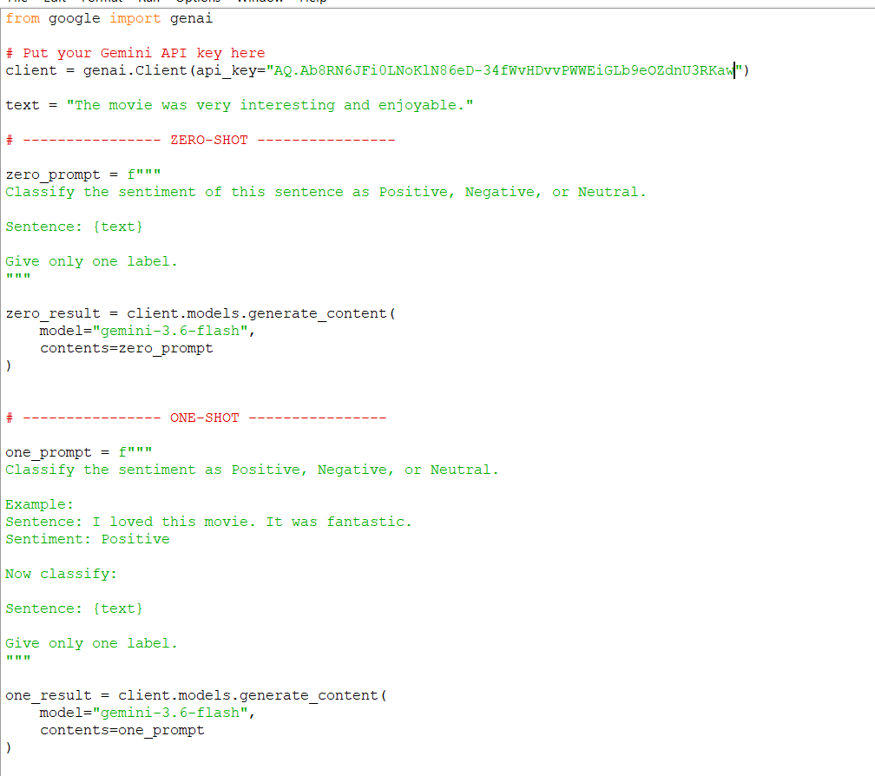

OUTPUT
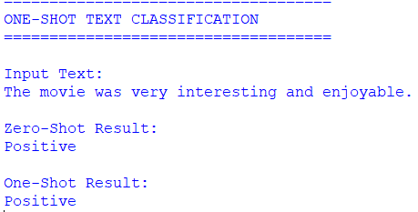

2.Simple AI Agent with Calculator Tool: Develop an AI agent that answers normal questions and uses a calculator tool whenever mathematical computation is required.
1. INTRODUCTION
An AI agent is a software system that can understand a user's request and decide what action should be performed. An AI agent can answer normal questions and use external tools when additional computation or information is required.
In this project, a simple AI agent is developed using Python and the Gemini API. The agent can answer general questions directly. When the user asks a mathematical question, the agent uses a calculator tool to perform the calculation.
For example, if the user asks "What is the capital of India?", the AI answers directly. If the user asks "What is 25 × 16?", the agent uses the calculator tool and returns the calculated result.

2. AIM
To develop a simple AI agent that answers normal questions and uses a calculator tool whenever mathematical computation is required.

3. OBJECTIVES
- To understand the concept of AI agents.
- To connect an AI agent with the Gemini API.
- To create a calculator tool using Python.
- To identify mathematical queries.
- To use the calculator for mathematical operations.
- To answer normal questions using the AI model.
- To demonstrate tool usage in an AI agent.

4. AI AGENT
An AI agent is a system that receives a user's input, understands the request, and decides how to respond.
The basic working process is:
User Input → AI Agent → Identify Task → Answer / Use Tool → Final Response
The agent can perform different actions depending on the input.

5. CALCULATOR TOOL
The calculator tool is a Python function that performs mathematical calculations.
It can be used for operations such as:
- Addition
- Subtraction
- Multiplication
- Division
- Percentage
- Power
For example:
25 × 16 = 400
The calculator tool helps the AI agent produce accurate numerical results.

6. METHODOLOGY
The system works in the following steps:
- The user enters a question.
- The AI agent receives the question.
- The agent checks whether mathematical calculation is required.
- If it is a normal question, Gemini generates the answer.
- If it is a mathematical question, the calculator function is used.
- The result is returned to the user.

7. TOOLS AND TECHNOLOGIES
The following technologies are used:
- Python
- Google Gemini API
- Google GenAI library
- Calculator function
- Python eval() function for basic demonstration
- Command Prompt / VS Code / IDLE

8. PYTHON IMPLEMENTATION
from google import genai

client = genai.Client(api_key="YOUR_API_KEY")

# Calculator Tool
def calculator(expression):
try:
result = eval(expression, {"__builtins__": {}}, {})
return result
except:
return "Invalid calculation"

# AI Agent
def ai_agent(question):

math_symbols = ["+", "-", "*", "/", "%"]

# Check whether calculation is required
if any(symbol in question for symbol in math_symbols):

expression = input("Enter calculation: ")

result = calculator(expression)

return "Calculator Result: " + str(result)

else:

response = client.models.generate_content(
model="YOUR_AVAILABLE_GEMINI_MODEL",
contents=question
)

return response.text

# User Input
question = input("Ask your question: ")

print("\nAI Agent:")
print(ai_agent(question))

9. CODE EXPLANATION
The genai library is imported to communicate with the Gemini API.
The calculator() function performs mathematical calculations.
The ai_agent() function acts as the main decision-making component. It checks whether the user's question contains mathematical operators.
If mathematical operators are found, the calculator tool is used. Otherwise, the question is sent to Gemini for a normal AI-generated response.
The final result is displayed to the user.

10. SAMPLE OUTUT
Normal Question
Ask your question: What is the capital of India?

AI Agent:
The capital of India is New Delhi.
Mathematical Question
Ask your question: Calculate 25 * 16

Enter calculation: 25 * 16

AI Agent:
Calculator Result: 400
Another Example
Ask your question: Calculate 500 / 25

Enter calculation: 500 / 25

AI Agent:
Calculator Result: 20.0

11. WORKFOW
The working of the AI agent can be represented as:
User Question
↓
AI Agent
↓
Is calculation required?
↓
YES → Calculator Tool → Calculate Result
NO → Gemini AI → Generate Answer
↓
Final Response

12. APPLICATIONS
This type of AI agent can be used in:
- Educational assistants.
- Mathematical learning systems.
- Student help applications.
- Chatbots.
- Customer support systems.
- Personal AI assistants.
- Productivity applications.

13. ADVANTAGES
- Simple to implement.
- Combines AI with an external tool.
- Provides accurate mathematical calculations.
- Can answer general questions.
- Demonstrates basic AI-agent behavior.
- Can be extended with additional tools.
14. LIMITATIONS
- The basic agent supports only simple calculations.
- The calculator tool needs proper input.
- API availability is required for normal questions.
- The basic implementation does not automatically extract complex mathematical expressions from natural language.

15. RESULT
The AI agent successfully handles two types of user requests. Normal questions are answered using the Gemini model, while mathematical questions are processed using the calculator tool.
The experiment demonstrates how an AI agent can select an appropriate tool depending on the user's requirement.

16. CONCLUSION
A simple AI agent with a calculator tool was successfully developed using Python and Gemini API. The agent can answer general questions and use a calculator when mathematical computation is required.
This project demonstrates the basic concept of tool-using AI agents, where an AI model can work together with external functions to perform specific tasks more reliably.

INPUT
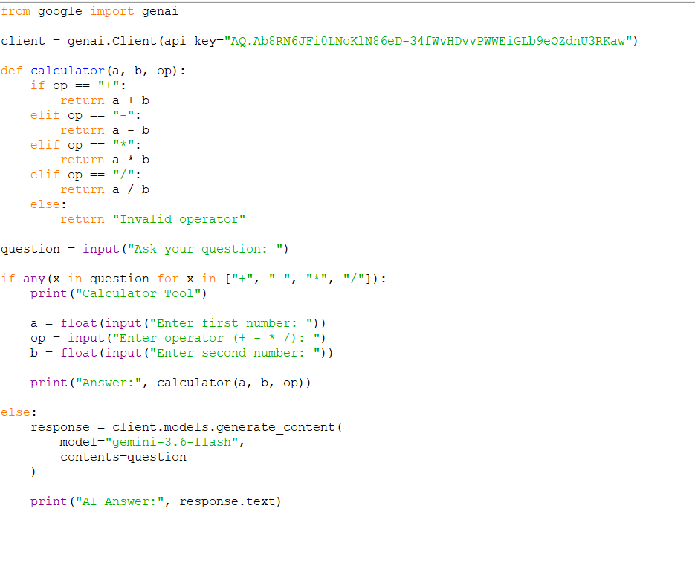
OUTPUT
